To create project name:-🡪

Project 🡪 create project -🡪software development🡪 scrum 🡪use Template🡪this web page display

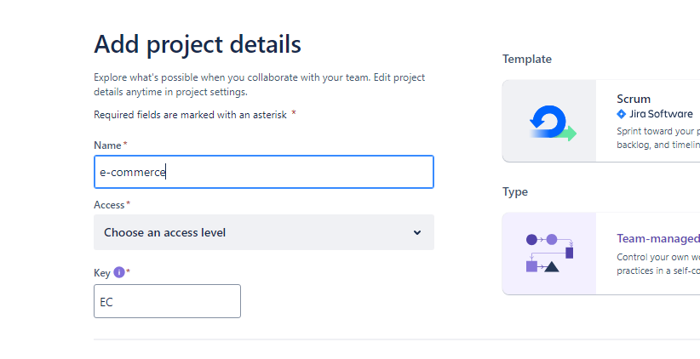

Access------------🡪 open and click on Next

To create team:🡪

More🡪team🡪create team-🡪add name

And your team will be created

But first of all you have to invite the team and write a email

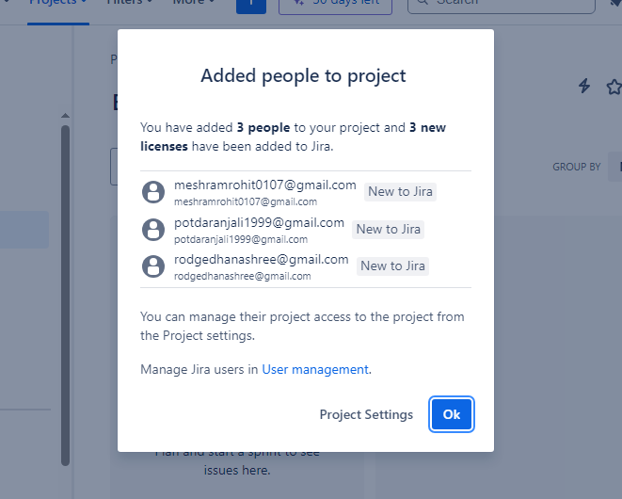

Assign task :🡪

You click the +

Give issue type -🡪option 1.task 2.bug 3.epic

Click create

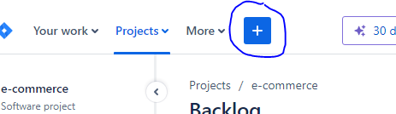

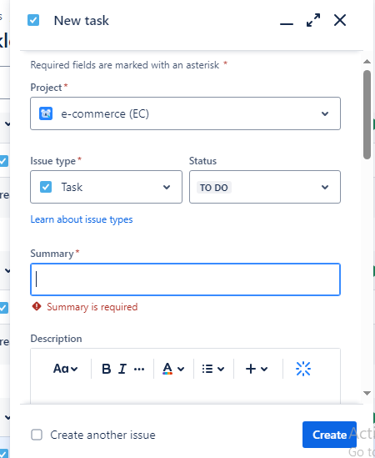

Now go to backlog

In backlog where write 1 you see the assign project

After this you have to create sprint

And then drag and drop from backlog to sprint

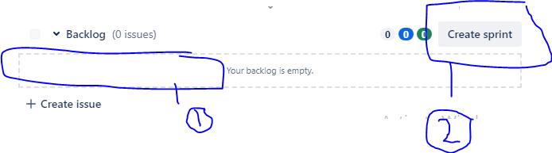

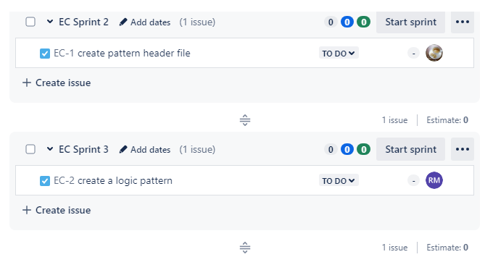

After this **START SPRINT**

Give duration

Start date

End date

Goal

Then click start .

